**Name Allahdad**

**Section D**

**CMS(023-22-0056)**

**Java Lab Task**

1. Write a java program to find the difference between largest and smallest element in an array of integers, first you need to find the largest element and smallest element, then compute the difference.

**Input**

**class Q1**

**{**

**public static void main(String args[])**

**{**

**int temp;**

**int arr[]={2,12,3,43};**

**for(int i=0;i<=3;i++)**

**{**

**for(int j=i+1;j<=3;j++)**

**{**

**if (arr[i]>arr[j])**

**{**

**temp=arr[i];**

**arr[i]=arr[j];**

**arr[j]=temp;**

**}**

**}**

**}**

**System.out.println("Smallest value is "+arr[0]);**

**System.out.println("Largest value is "+arr[3]);**

**System.out.println("Differnce is "+(arr[3]-arr[0]));**

**}**

**}**

**Output**

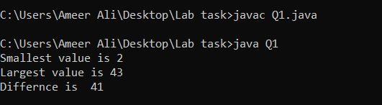

2.Write a Java program which takes input from user and check either number is prime number or not.

**Input**

**import java.util.Scanner;**

**class Q2**

**{**

**public static void main(String args[])**

**{**

**Scanner input=new Scanner(System.in);**

**System.out.print("Enter the any positive integer number :");**

**int no=input.nextInt();**

**int x=0;**

**for(int i=2;i<=10;i++)**

**{**

**if(no%i==0)**

**{**

**System.out.print(no+": this is not prime number");**

**x=1;**

**break;**

**}**

**}**

**if(x==0)**

**{**

**System.out.print(no+": this is prime number");**

**}**

**}**

**}**

**Output**

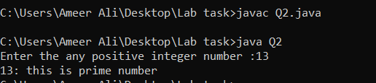

3.Write a Java program in which you have to use public, private, and protected specifier for instance variables or for class.

Input

class Q3

{

private int id=1122;

public String name="Allahdad Chachar";

protected String uni="Sukkur iba university";

}

class A extends Q3

{

void display()

{

System.out.println("Name:"+name);

System.out.println("university:"+uni);

System.out.println("id:");

//we canot use beacuse of private

}

public static void main(String args[])

{

A obj1=new A();

obj1.display();

}

}

Output

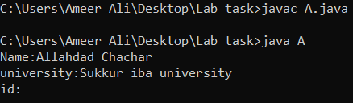

4.Write a java program in which create class Employee and it derive Teacher class. Perform method overloading and method overriding that perform any mathematical computation.

Input

class Employee

{

//method with one parameter

double mymethod(double num)

{

return 1.2*num*num;

}

//method with double parameter

double mymethod(double num1,double num2)

{

return 2.1*num1*num2;

}

}

class Teacher extends Employee

{

//method with one parameter

double mymethod(double num)

{

return 1*num*num;

}

//method with double parameter

int mymethod(int num1,int num2)

{

return 3.1*num1*num2;

}

}

class Task4

{

public static void main(String args[])

{

Teacher obj1=new Teacher();

System.out.println("Area of cicle by using Method Overiding.");

System.out.println("Area of circle :"+obj1.mymethod(2.1));

System.out.println("Parameter of rectangle by using Method Oveloading.");

System.out.println("Rectangle :"+obj1.mymethod(2,3));

}

}

Output

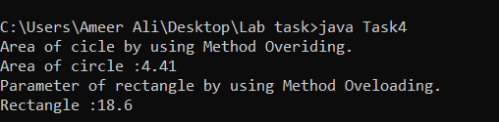

5.Write a program to print the area and perimeter of a triangle having sides of 6,8,and 10 units by creating class named ‘Triangle’ without any parameter in its constructor.

Input

class Triangle{

int[] s={6,8,10};

double p,semi,a;

//constructor without parameter;

Triangle()

{

//Parameter

p=(s[0]+s[1]+s[2]);

System.out.println("The parameter of triangle is: "+p);

//Area

semi=p/2;

a=semi*(semi-(s[0]))*(semi-(s[1]))*(semi-(s[2])) ;

a=Math.sqrt(a);

System.out.println("The Area of triangle is: "+a);

}

}

class Task5 extends Triangle{

public static void main(String[] args){

Triangle t = new Triangle();

}

}

Output

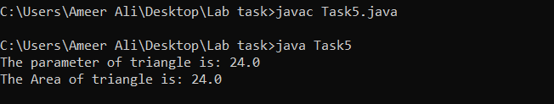

6.Create a class circle class with radius as data memer. Create two contructors (no argument, and two argument) and a method calculate circumference.

Input

//circumference of circle=2pi*r

class circle

{

double radius,cir,diameter;

circle()

{

this.radius=3;

}

circle(double radius,double diameter)

{

this.radius=radius;

this.diameter=diameter;

}

double display()

{

return cir=2*3.14*radius;

}

}

class Task6

{

public static void main(String args[])

{

circle c1=new circle();

System.out.println("Without parameter");

System.out.println("The circumference of circle is "+c1.display());

circle c2=new circle(4,3);

System.out.println("*****************");

System.out.println("With two parameter parameter");

System.out.println("The circumference of circle is "+c2.display());

}

}

Output

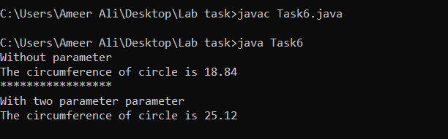

7.Create a class **Account** with balance as data member. Create two constructors (no argument, and two arguments) and methods to withdraw and deposit balance.

Input

import java.util.Scanner;

class Account

{

Scanner input=new Scanner(System.in);

int balance=5000;

int withdraw,deposit,total;

//without argument constructor

Account()

{

System.out.println("Enter the withdraw amount:");

this.withdraw=input.nextInt();

System.out.println("Enter the Deposit amount:");

this.deposit=input.nextInt();

}

//with two argument constructor

Account(int withdraw,int deposit)

{

this.withdraw=withdraw;

this.deposit=deposit;

}

int display()

{

int total;

total=balance+deposit-withdraw;

return total;

}

}

class Task7

{

public static void main(String args[])

{

Scanner input=new Scanner(System.in);

System.out.println("Without argument");

Account obj1=new Account();

System.out.println("Remaining balance is "+obj1.display());

System.out.println("*************************\n");

System.out.println("With two arguments");

System.out.println("Enter the withdraw amount:");

int x=input.nextInt();

System.out.println("Enter the Deposit amount:");

int y=input.nextInt();

Account obj2=new Account(x,y);

System.out.println("Remaining balance is "+obj2.display());

}

}

Output

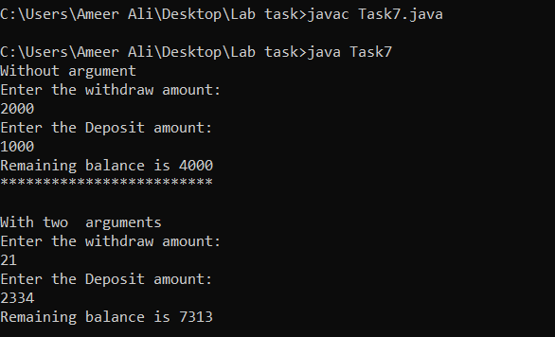

8.Write a java program which perform Multilevel inheritance on the following classes

* Parent class Teacher, two instance variable name, and grade. One method BioData( ) that display name, and grade.
* Subclass HoD, one instance variable dept. One method BioData() that display name, grade, and dept.
* Subclass Dean, one instance variable field(Science, Technology). One method BioData() that display name, grade, and field.

Input

class Teacher

{

String name;

int grade;

Teacher()

{

this.name="Allahdad";

this.grade=17;

}

void biodata()

{

System.out.println("Name:"+name);

System.out.println("Grade:"+grade);

}

}

class HOD extends Teacher

{

String dep;

HOD()

{

this.dep="Computer Science";

}

void biodata()

{

System.out.println("Name:"+name);

System.out.println("Grade:"+grade);

System.out.println("Department:"+dep);

}

}

class Dean extends HOD

{

String field;

Dean()

{

this.field="Science";

}

void biodata()

{

System.out.println("Name:"+name);

System.out.println("Grade:"+grade);

System.out.println("Department:"+dep);

System.out.println("Field:"+field);

}

}

class Task8

{

public static void main(String args[])

{

Dean obj1=new Dean();

obj1.biodata();

}

}

Output

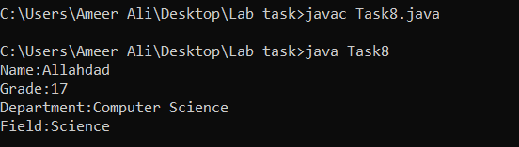

10.Create class named as Vehicle, that contains two variables name, and model. It should display name, and model using Detail method of other class Mehran. Create another class Mehran that contains one variable price. It should display price using Info() method of Vehicle class.

Input

class Vehicle

{

String name;

int model;

Vehicle()

{

this.name="Mehran";

this.model=2015;

}

void display()

{

System.out.println("Name"+name);

System.out.println("Model"+model);

}

}

class Mehran extends Vehicle

{

double price;

Mehran()

{

this.price=2000000;

}

void display()

{

System.out.println("Name"+name);

System.out.println("Price"+price);

System.out.println("Model"+model);

}

}

class Task10

{

public static void main(String args[])

{

Mehran obj1=new Mehran();

obj1.display();

}

}

Output

